**FIN810: Final Exam Review and Sample questions**

**Topics**

Stock evaluations:

* risk and return tradeoff
* market risk (beta)
* correlation

Return models: CAPM and Fama French Models

Hypothesis testing: Returns anomalies (Mean comparison)

Abnormal returns: CAR based on CAPM or Fama French Models

Portfolio: n-asset portfolio return and risk; portfolio optimization (global minimal variance portfolio; min risk portfolio given a target rate of return; AND THE GRAPH, BRIEFLY INTERPRET THE RESULTS max Sharpe ratio portfolio)

SAS skills:

1. Import/ export data: different data types, including SAS programming produced dataset (proc import; proc export; library; libname)
2. Merge data: one to one; one to many; many to many (proc sql, merge, etc)
3. Format data in SAS: set data; create new variables; rename variables; delete variables; format variables; convert variables; etc.
4. Save SAS output dataset.
5. Proc contents; Proc means; Proc univariate; Proc sort; Proc sql; Proc reg; proc ttest;

**Sample Questions**

1. Portfolio optimization (A two-asset example):
   1. SMCMBA: [FIN810 optimization_bac_msft_student](https://www.smcmba.com/courses/course-list-my-courses/1113--fin810-financial-analytics-spring-2017-sv/documents/files/47515--fin810-optimization-bac-msft-student)
   2. I will post answer keys in the class on June 15
2. Hypothesis statement: Chapter 7 P324; 12 (a)
3. Hypothesis testing: Return anomalies (Proc TTest)

For example, test the calendar return anomalies for Fama French 3 factors.

Returns around Christmas – Whether there was a statistically significant difference between the mean returns on trading days between 12/20 and 12/30 and mean return during the rest of the year (Fama French daily data from 1990 to 2016).

SAS code on SAS studio, titled as “Final sample Holiday anormalies.sas”.

Reject null for market risk premium, SMB. Cannot reject null for HML.

For the variable market risk premium:mrt-rf-d, the results are as follow.

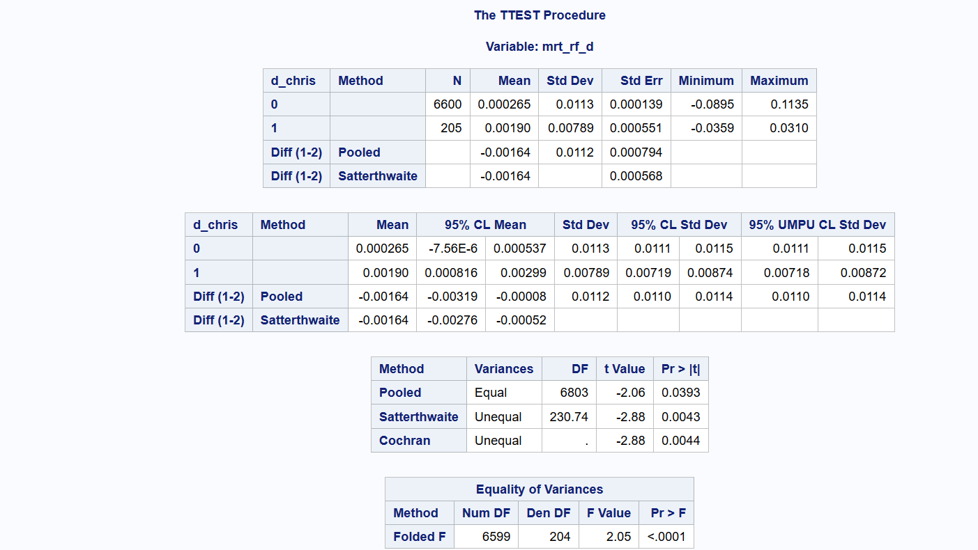

# All p-value<0.05. unequal p values<0.01. reject null.

# chris returns are not equal to non chris returns.

P value <.0001, reject the null of equal variance. Conceptually, the test is to compare Christmas vs non Christmas. It could be unequal variance.

1. Return anomalies: Event study (EXCEL)
   1. CARs for M&As: Microsoft LinkedIn crsp 1516 data (Announcement day: June 13, 2016)
   2. Your HW of any event study.